EKTA ENTERPRISE
Phone: 9979186216
Phone: 9979186220
Email: farukekta@gmail.com
Website: https://ektaenterprise216.github.io/EKTAENTERPRISE/
Instagram Id: instagram.com/ektaenterprise216/
Facebook Id: facebook.com/EKTAEnterprise216
Corrugated Boxes (All size in inch) (All 3 or 5 Ply)
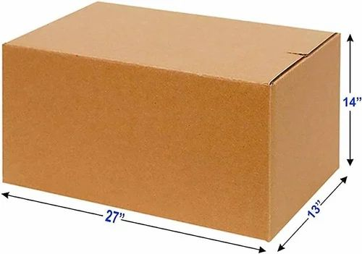
2.25 x 1.5 x 4.5
4 x 2 x 4
9 X 6 X 3
9 X 6 X 4.5
9 X 6 X 2
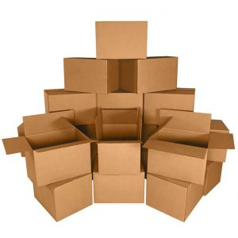
10 X 6 X 2
9 X 6 X 2.5
9 X 7 X 3.5
10 X 4 X 4
8 X 5 X 2
8 X 5 X 3
6 X 5 X 2
6 x 4 x 3.5
6 x 6 x 3
8 X 6 X 6
8 X 4 X 8
7.75 x 2.5 x 8.75
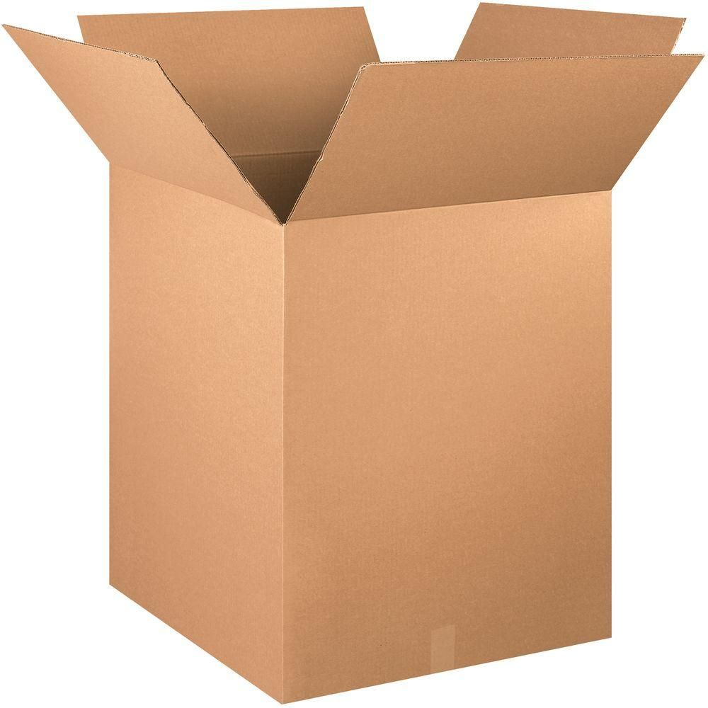
7 X 5 X 4
7 X 4.5 X 3.5
8.25 x 4.75 x 6.25
5 X 5 X 5
4 X 4 X 4
6 X 6 X 6
7.5 X 7.5 X 7.5
7.5 x 2.5 x 9
9 X 8 X 8
9 x 2.5 x 11.5
4 X 2.5 X 4
5 X 4.5 X 3.5
5 X 5 X 11
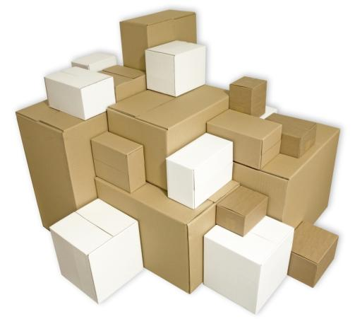
5 x 2 x 9
5.5 X 5 X 17
7.5 x 3 x 18
7 x 5.75 x 19.5
3 X 3 X 12.5
9.5 x 8 x 13
13 X 8 X 7
16 X 4 X 16
14 X 3 X 16
16 X 2 X 16
11 X 11 X 6
12 x 10 x 4
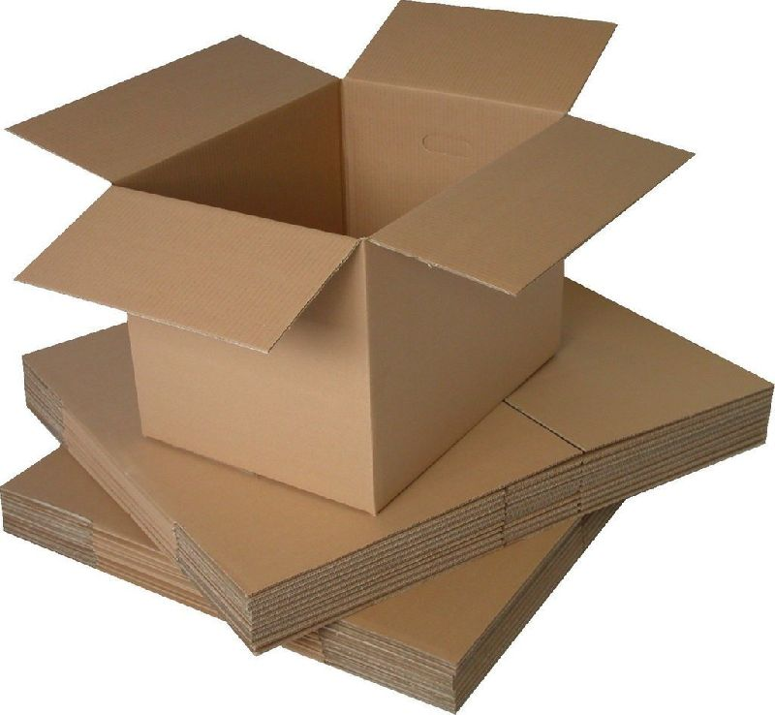
12 x 4.5 x 2.5
12 X 5 X 6
12 X 12 X 12
12 X 10 X 8
15 X 11 X 9
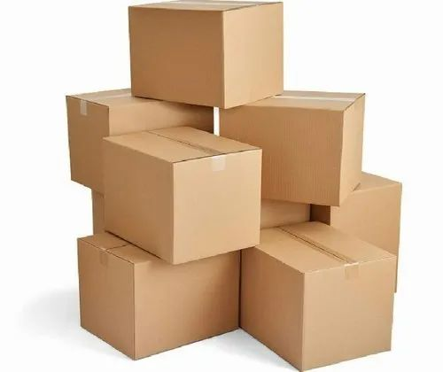



Frame Box (All size in inch) (Ply All 3 or 5)
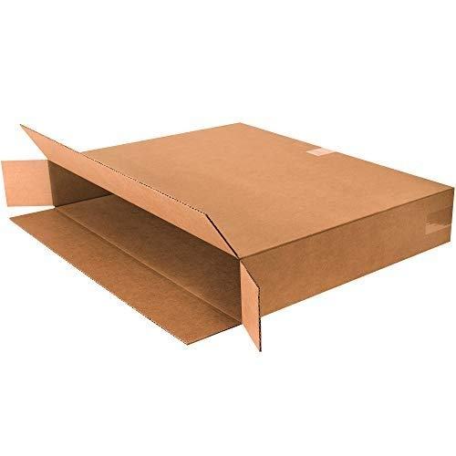
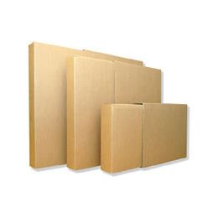
12 X 1.25 X 12
12 X 1.25 X 18
13 x 2.5 x 13
14 X 1.25 X 20
6 X 1.25 X 15
9.50 x 1.25 x 12.50

Mailer Box / Flat Auto Lock Box (All size in inch) (Ply All 3)
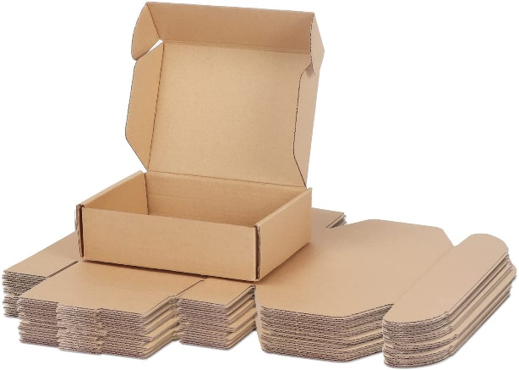
2.5 x 2 x 1.5 - Self Locking flat box
2.5 x 2 x 1.5 - Self Locking flat box white
2.5 x 2 x 2.5 - Self Locking flat box
2.5 x 2 x 2.5 - Self Locking flat box white
3.5 x 3 x 1.5 - Self Locking flat box
3.5 x 3 x 1.5 - Self Locking flat box white
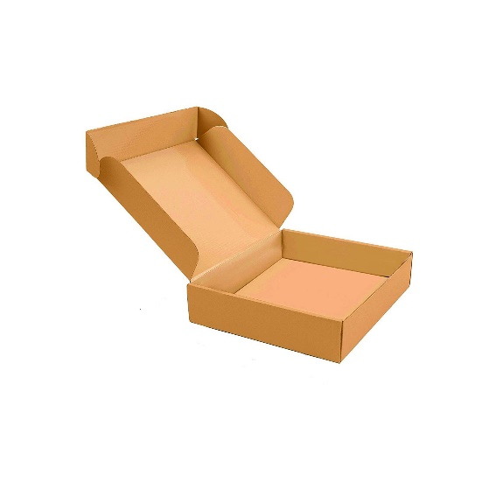
3.5 x 3 x 2.5 - Self Locking flat box
3.5 x 3 x 2.5 - Self Locking flat box white
4.5 x 3 x 1.5 - Self Locking flat box
4.5 x 3 x 1.5 - Self Locking flat box white
4.5 x 3 x 2.5 - Self Locking flat box
4.5 x 3 x 2.5 - Self Locking flat box white
5.5 x 3 x 1.5 - Self Locking flat box
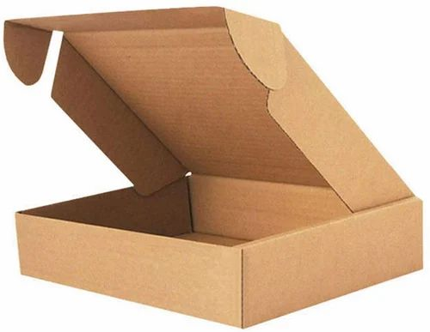
5.5 x 3 x 1.5 - Self Locking flat box white
5.5 x 3 x 2.5 - Self Locking flat box
5.5 x 3 x 2.5 - Self Locking flat box white
4 X 4 X 1.5 - Self Locking flat box
4 X 4 X 1.5 - Self Locking flat box white
5 x 5 x 2 - Self Locking flat box
7 x 7 x 2 - Self Locking flat box
6 X 4 X 2 – Self Locking flat box
6 X 4 X 2 – Self Locking flat box white
6 x 4 x 2 – Self Locking flat box black
6 x 5 x 1.5 – Self Locking flat box
7 x 2 x 1.5 - Self Locking flat box
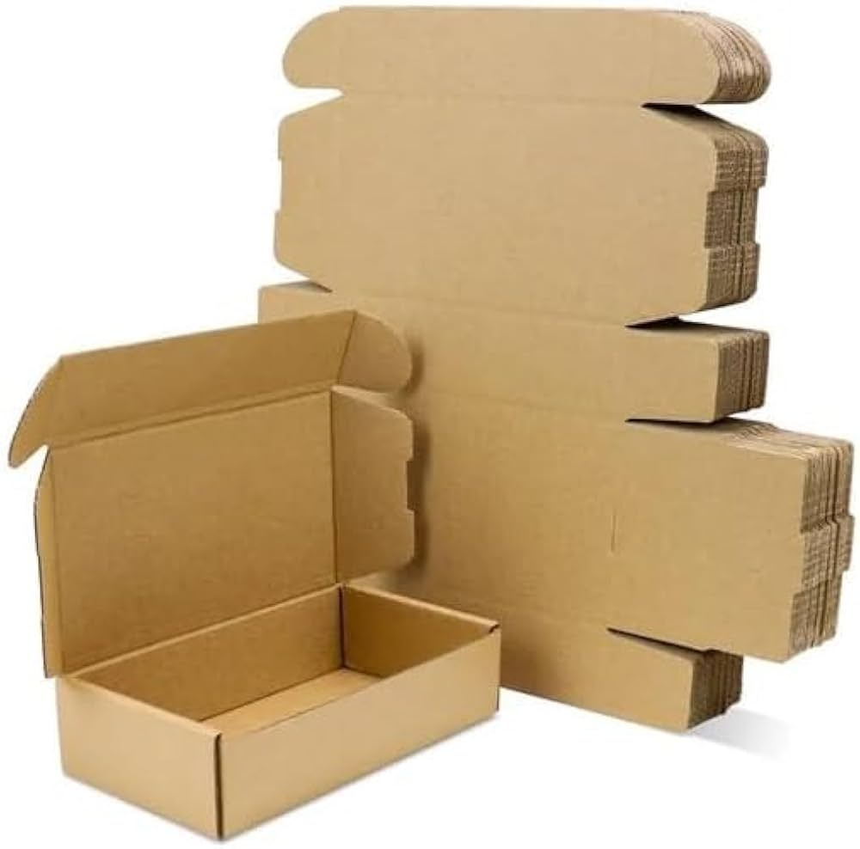
7.5 X 4 X 1.5 - Self Locking flat box
8 X 5 X 2 - Self Locking flat box
9 x 6 x 4- Self Locking flat box
10 x 8 x 1.25- Self Locking flat box
13 x 7 x 3- Self Locking flat box
7 X 6 X 1.75 – Self Locking flat box
7 X 6 X 1.75 – Self Locking flat box white
8 x 5 x 2 - Self Locking flat box white
7 X 5 X 2.75 – Self Locking flat box
7 X 5 X 2.75 – Self Locking flat box white
7 x 4 x 2 - Self Locking flat box
7 x 4 x 2 - Self Locking flat box white
7 x 5 x 4 - Self Locking flat box
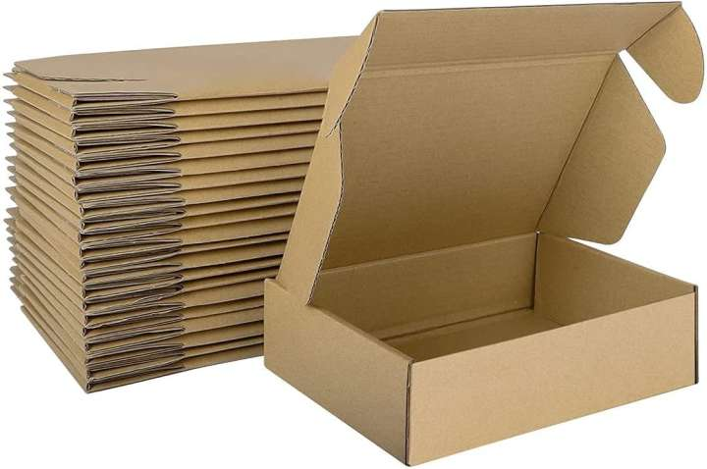
8 x 8 x 2.5 – self Locking flat box
8 x 8 x 4 - Self Locking flat box
9 X 6 X 3 – Self Locking flat box
9 x 6 x 2 - Self Locking flat box
9 x 6 x 2 - Self Locking flat box white
10.5 x 6 x 1.5 - Self Locking flat box
10.5 x 6 x 1.5 - Self Locking flat box white
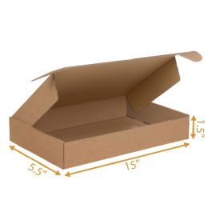
9.5 x 9.5 x 1.5 – Self Locking flat box
10.50 x 10 x 2.50 - Self Locking flat box
12 x 10 x 1.50 - Self Locking flat box
12 x 10 x 2.50 – Self Locking flat box
21 x 10 x 2 - Self Locking flat box

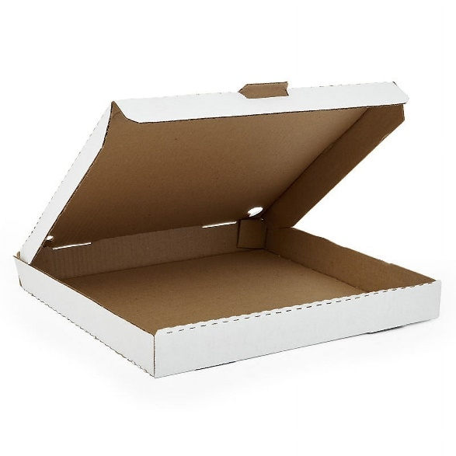
Pizza Box: (White and Brown Available) (All size in inch) (Ply All 3)
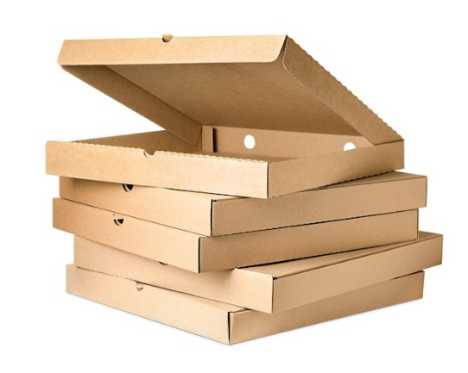
12 X 12 X 1.5 pizza
10 X 10 X 1.5 pizza
9 x 9 x 1.5 pizza
8 X 8 X 1.5 pizza
7 x 7 x 1.5 pizza

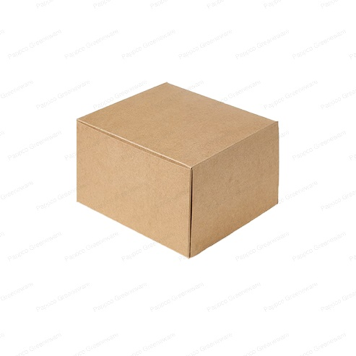
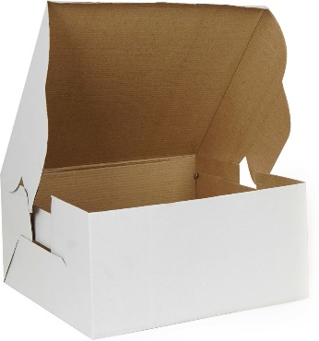
Cake Box:
8 x 8 x 5 cake box (plan and printed)
10 x 10 x 5 cake box (plan and printed)
8 x 8 base
10 x 10 base

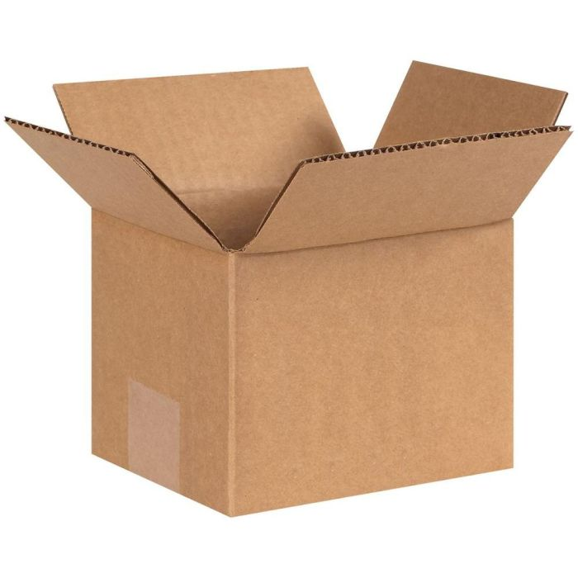
5 Ply Box:
18 X 12 X 12 - 5ply
27 x 18 x 12 – 5ply
24 X 18 X 18 - 5ply
30 X 20 X 20 - 5ply
20 X 20 X 20 - 5ply
15 X 15 X 10 - 5ply

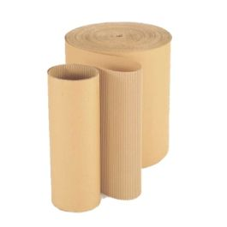
2Ply Corrugated Roll Size:
18 Inch,
20 Inch,
22 Inch, 24 Inch…. Up to 52 Inch

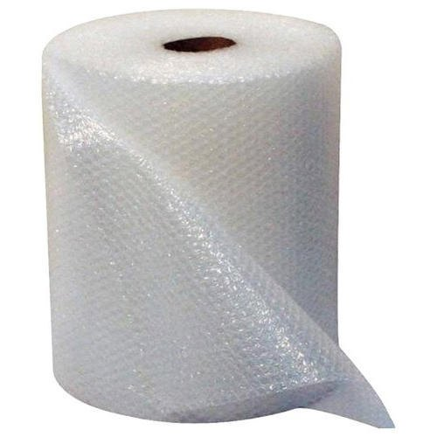
Bubble Roll:
1 meter X 100 Meter
0.5 meter X 100 Meter
30 cm X 100 Meter
1 meter X 50 Meter
0.5 meter X 50 Meter
30 cm X 50 Meter
1 meter X 25 Meter
0.5 meter X 25 Meter
30 cm X 25 Meter

Thermocol Sheets:
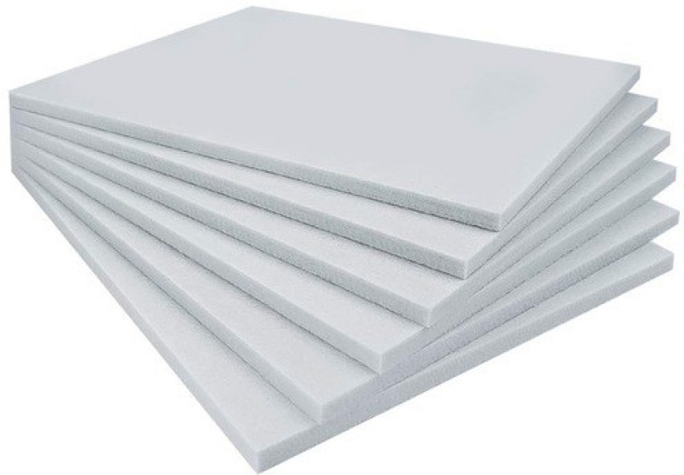
All sheets are 1 Meter X 0.5 Meter size
50 MM - 18 sheets
25 mm - 40 sheet
20 mm - 45 sheets
15 mm - 62 sheets
10 mm - 85 sheets

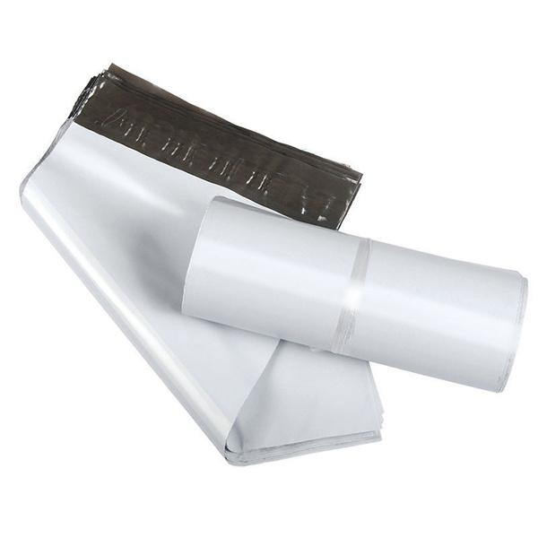
Polybag:
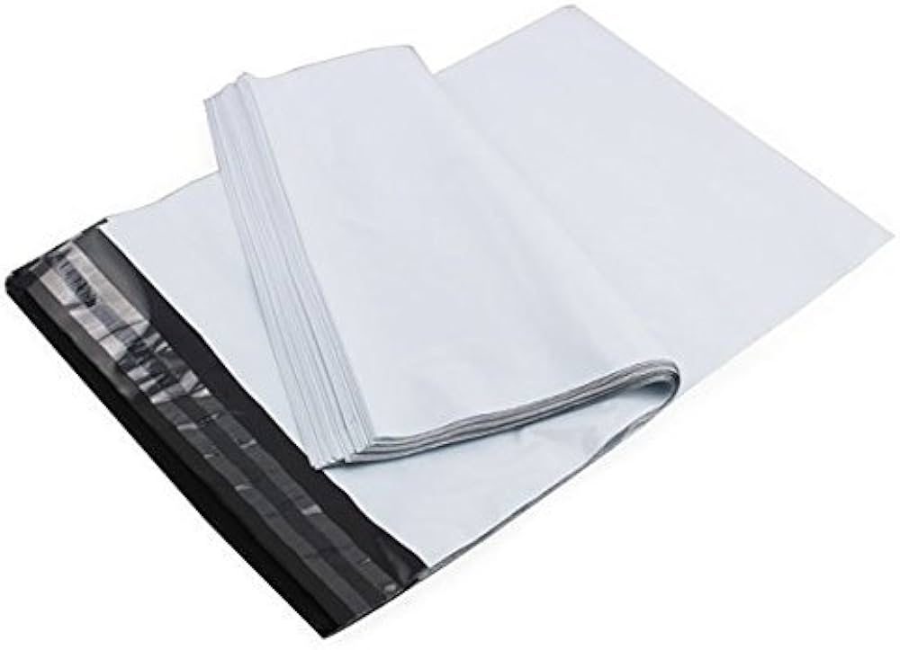
6*8
8*10
10*12
12*14
12*16
14*17
14*18
16*20
20*24

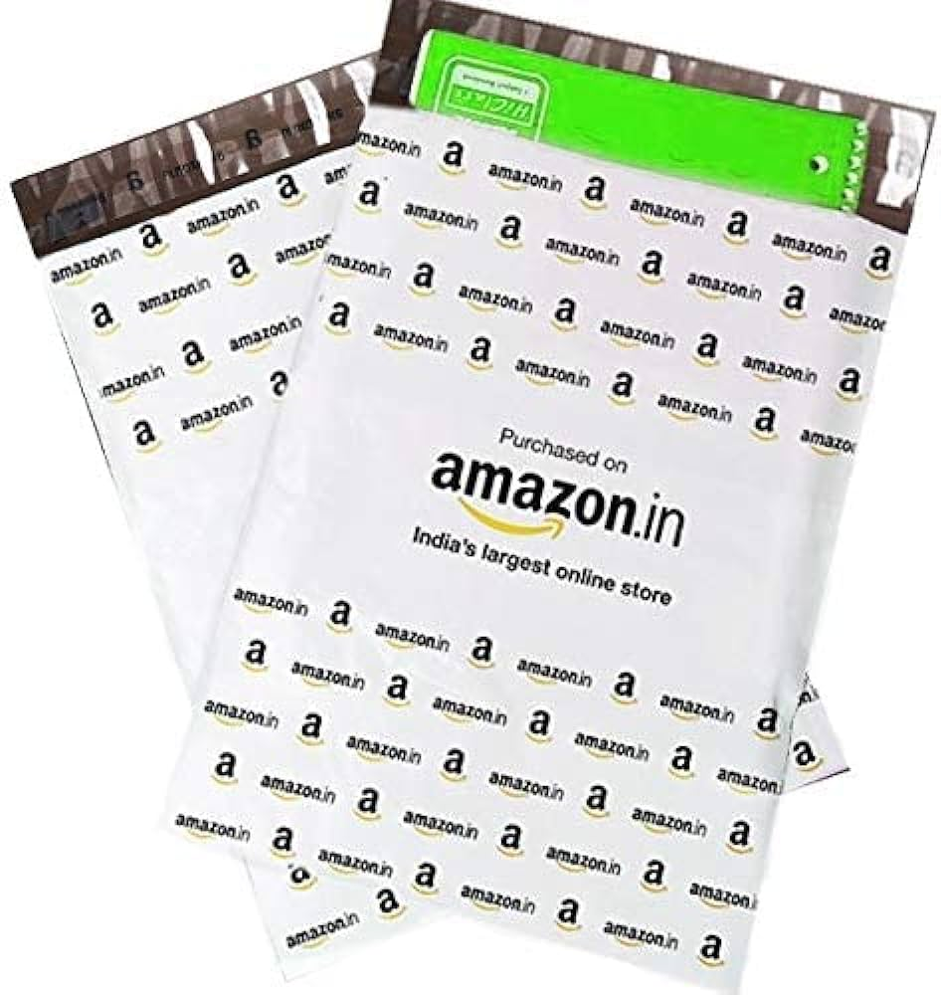
Amazon Courier Bags | Amazon Polybag:
6X8 = 2.5
8X11 = 2.35
10X12 = 2.65
12X14 = 3.25
12.5X16 = 3.5
14X17 = 4.5
17X19 = 7.75
21X23 = 10.99

All colors Bopp Tap and PVC tap:
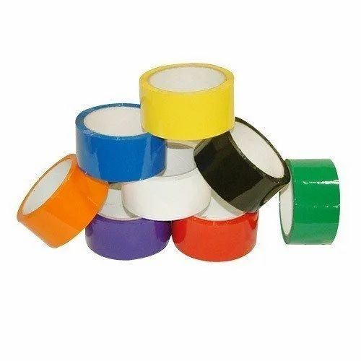

All colors

Packing Brown Tap 3 Inch x 100 Meter Tap:
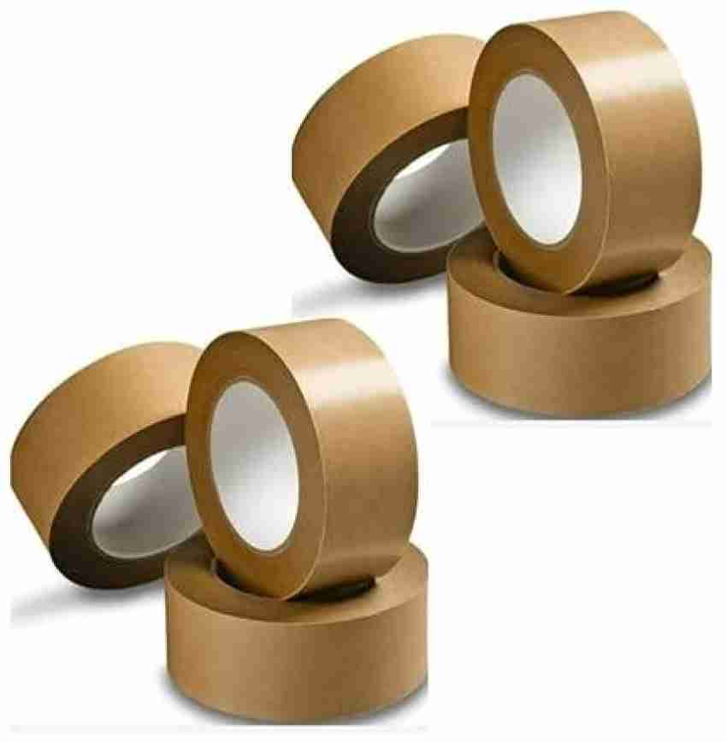
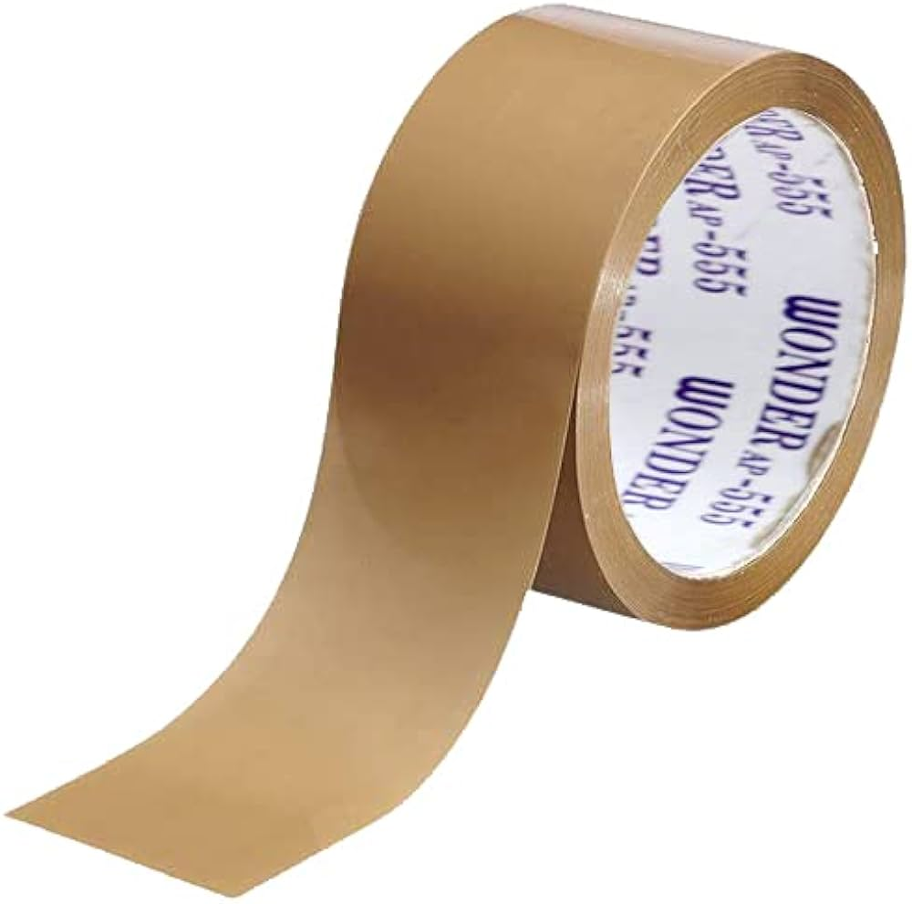

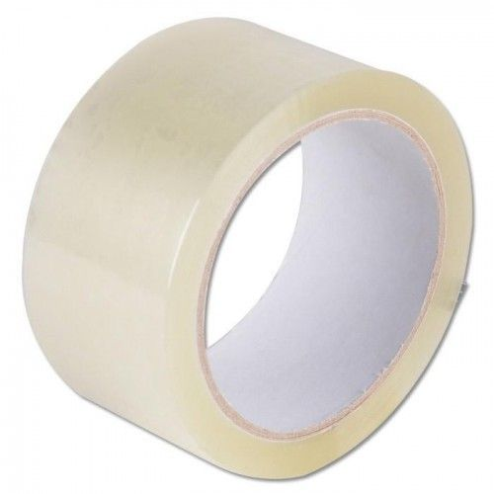
Transparent Tap:
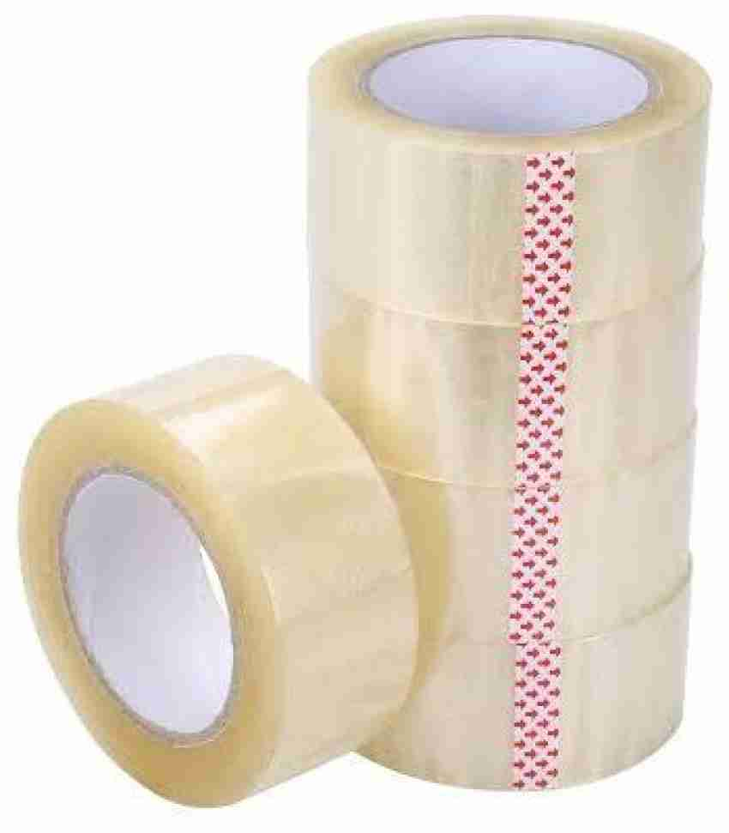

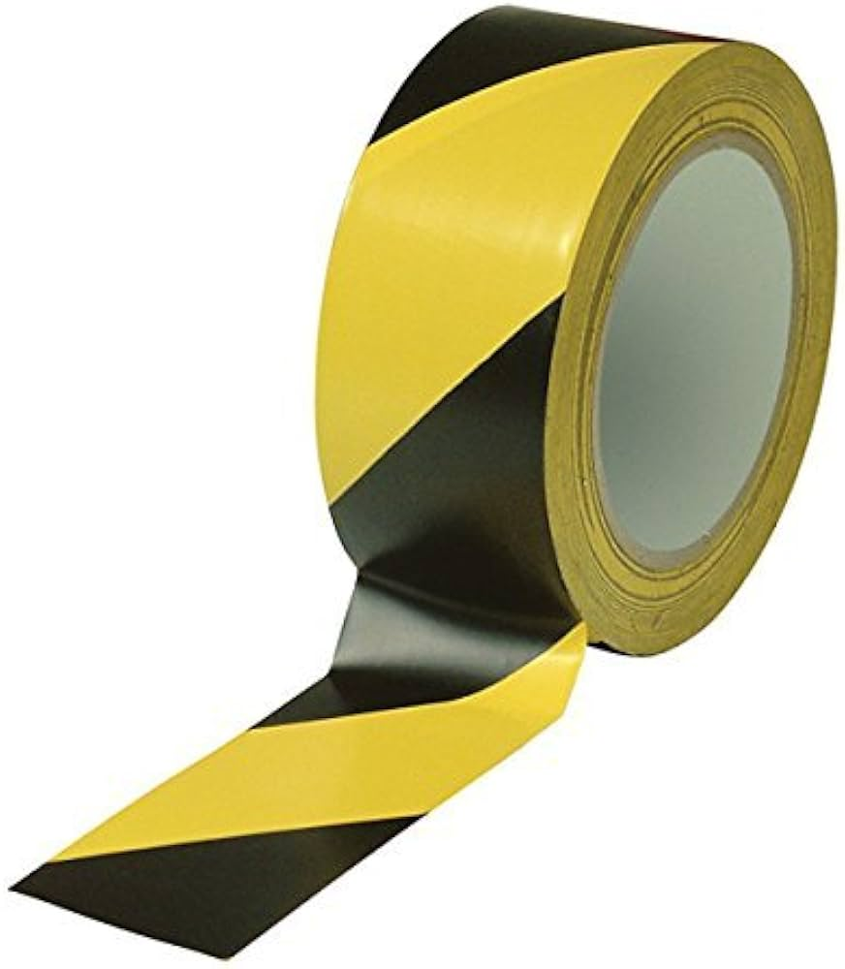
Floor Marking Tape:
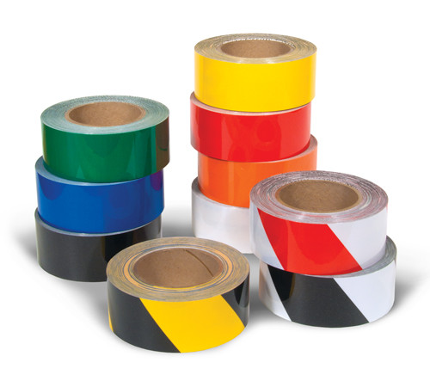

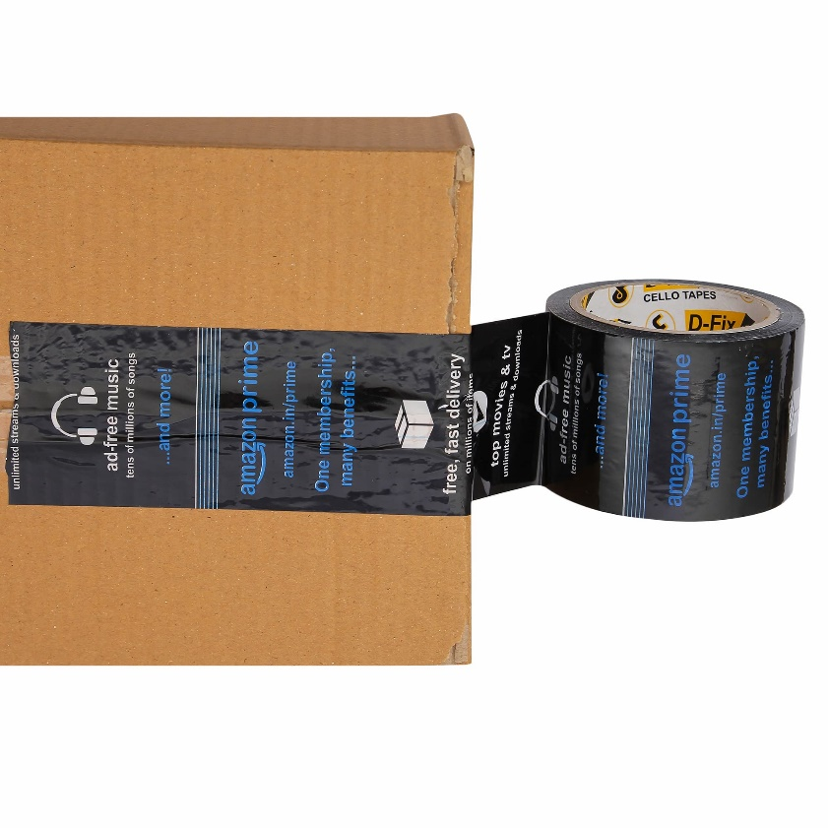
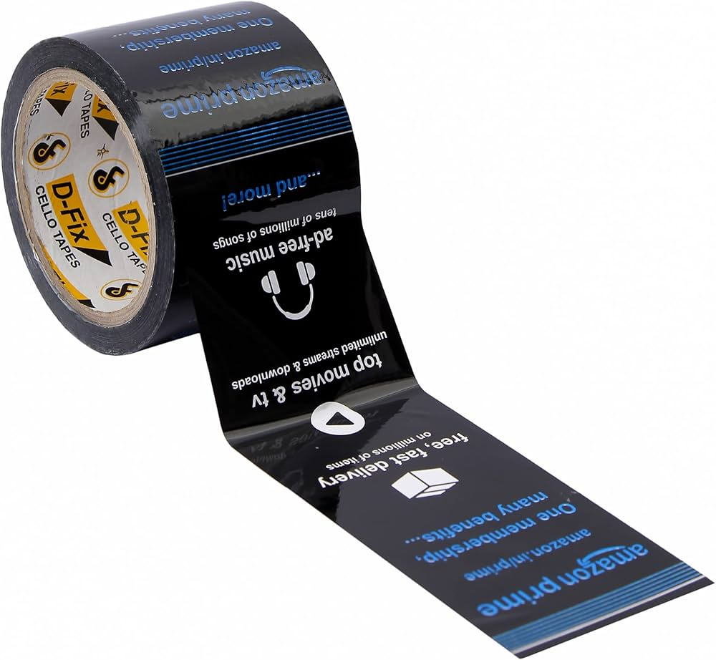
Amazon Tap:

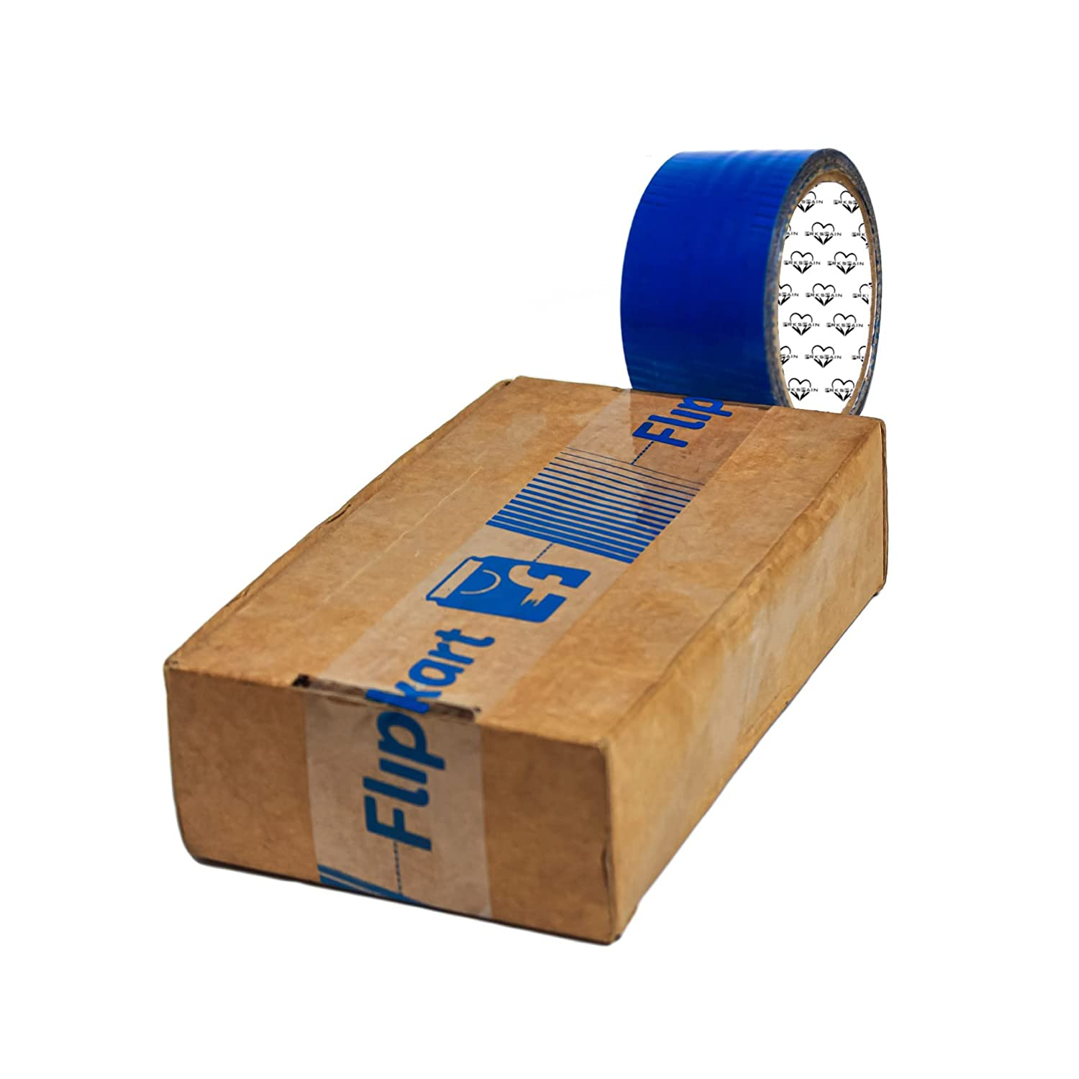
Flipkart Tape:
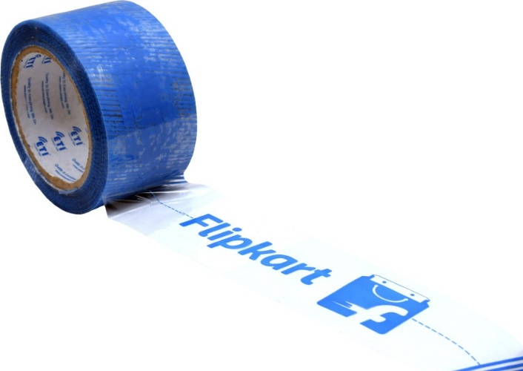

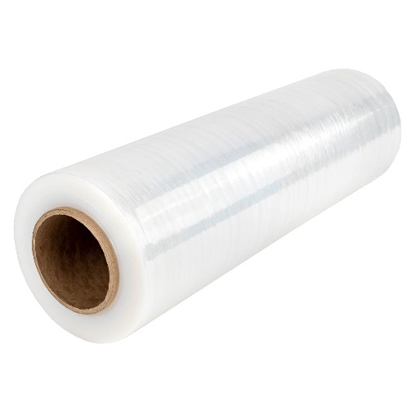
Stretch Wrap Film Roll:
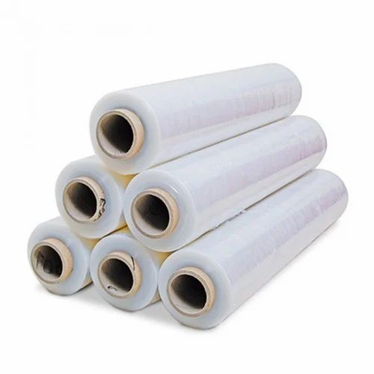
2 inch
4 inch
6 inch
8 inch
12 inch
18 inch

Kraft Paper / Brown and Golden:
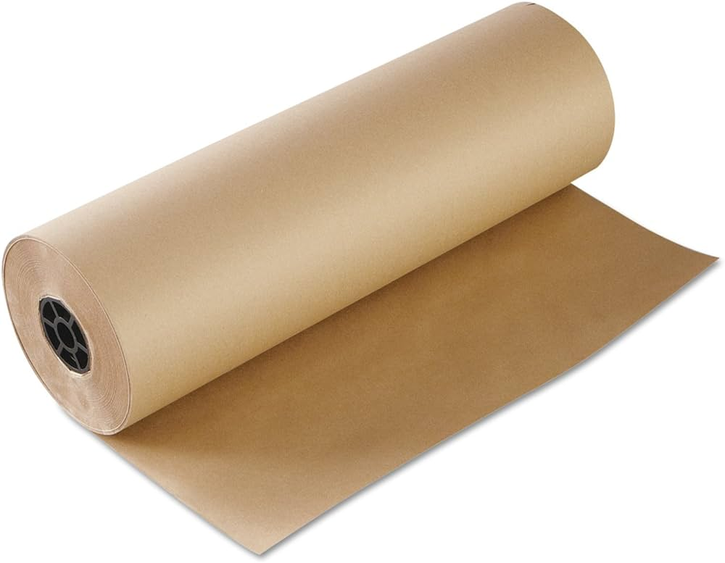
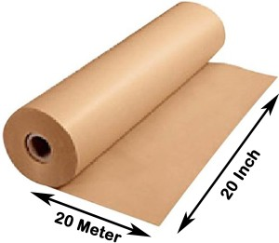

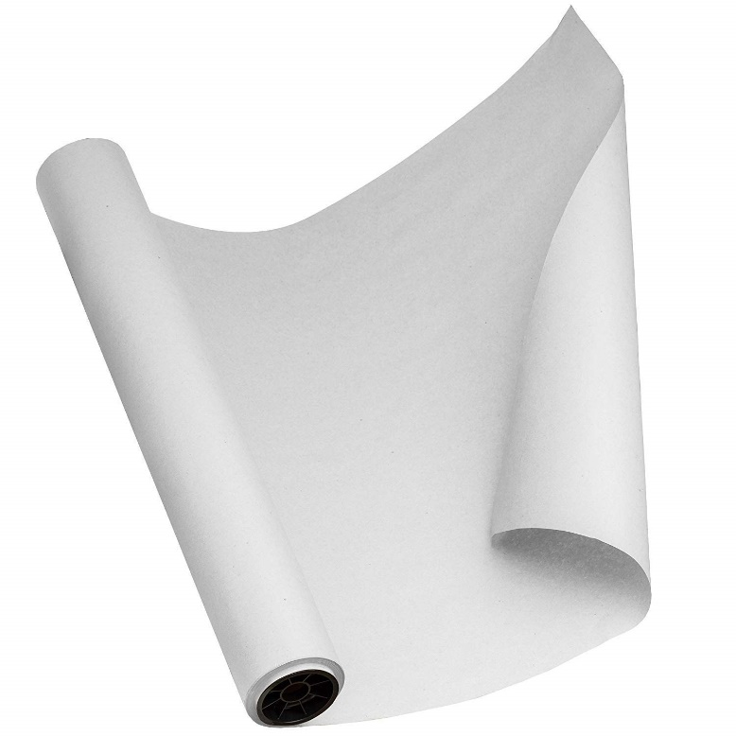
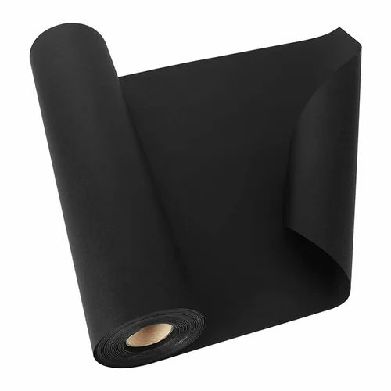
Black And White Paper:

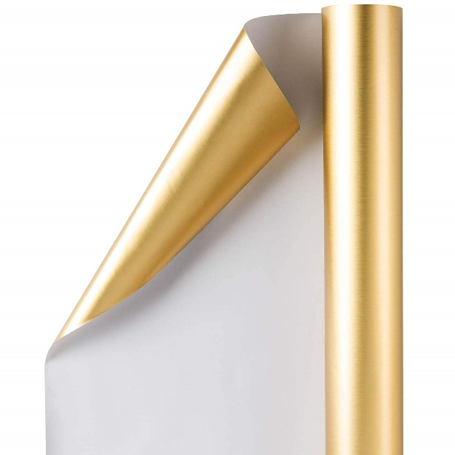
Golden, Copper and Silver Paper:
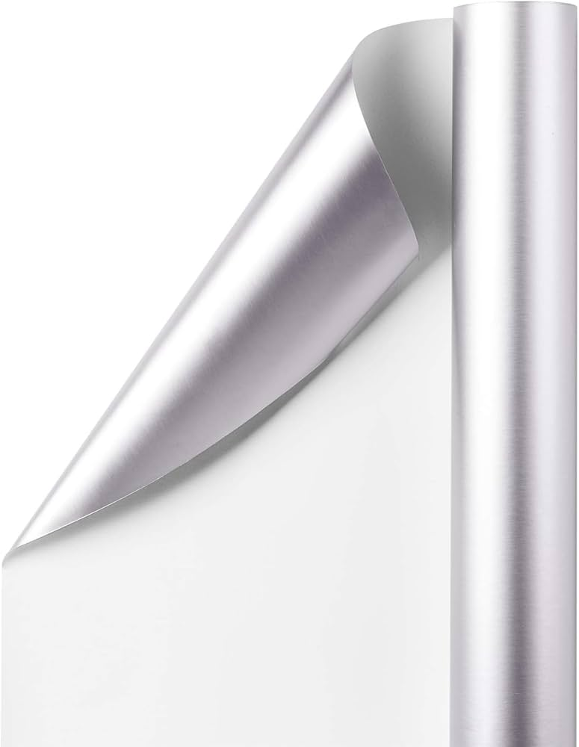


Thank You for Exploring EKTA Enterprise’s Corrugated Box Collection!
We hope this catalog has provided you with detailed insights into our range of high-quality, durable corrugated boxes, tailored to meet diverse business needs. At EKTA Enterprise, we are committed to delivering reliable packaging solutions designed for performance, sustainability, and protection.
If you have any questions or require further assistance, please feel free to reach out. We are here to support your business with the perfect packaging solutions. Visit our website for the latest updates and product additions!

Contact Us:
Phone: 9979186216
Phone: 9979186220
Email: farukekta@gmail.com
Website: https://ektaenterprise216.github.io/EKTAENTERPRISE/

Thank you for choosing EKTA Enterprise!

